MAURITIUS
Mauritius will enchant you; will uplift your soul, making you feel that you belong to the chosen few. Every visitor enjoys personal attention. Every encounter is an opportunity to discover a friendly face. Behind each smile lies the promise of a unique holiday. The contrast of a multitude of colours and tastes, the island, set in its turquoise sea, is an oasis of peace and tranquillity. Mauritius, a melting pot where past and present are smoothly blended together, offers an essential beauty that will compel to return to its shores time and time again. May your stay with us remain engraved in your memory forever.

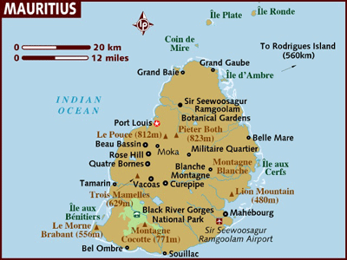

GEOGRAPHY
Mauritius is located approximately 2000 kilometres to the south eastern coast of Africa and lies east of Madagascar on 20°5, 57.5E. The country covers an area of 1865km_ with 330 kilometres of coastline. Mauritius is 45km in width and 65km in length.

VISA:
A visitor must be in possession of a valid passport and a return or onward ticket. A visitor’s visa (on arrival) is normally granted for a period of two weeks to one month upon arrival, to almost all holders of a valid passport, with one or two exceptions.

HOW TO GET THERE:
INTERNATIONAL AIRPORT: there is one international airport in Mauritius namely the Sir Seewoosagur Ramgoolam international airport. The airport is 45 mins from the capital of Mauritius Port Louis.

FLIGHTS INTO MAURITIUS:
Direct Flight is Air Mauritius (MK) ex BOM flying thrice a week – Monday, Wednesday & Friday. Return flights from Mauritius on MK thrice a week – Tuesdays, Thursday & Sunday

Flight timings on MK
BOM MRU
0210 0640

MRU BOM
1630 0010

CURRENCY:
The monetary unit is the Mauritian Rupee (MUR) which is divided into 100 cents (cs)

1 MUR = 1.36 INR
1 USD = 28.73 MUR
1 EUR = 42 MUR

GETTING AROUND:

Air: Air Mauritius operates daily flights connecting Plaisance Airport and Rodrigues (flight time - 1 hour 15 minutes).
Helicopter: Helicopters are available for transfers and sightseeing tours
Car: One major highway runs north to south, otherwise a good network of paved, if sometimes narrow, roads cover the island. Traffic drives, erratically, on the left.
Numerous car hire firms include major international and independent firms. Prices vary widely starting from 600 rupees per day.
Regulations: Drivers are required to be over 18 years old. Speed limits are 90kph (50mph) on the motorway and 50kph (31mph) in built-up areas. Seatbelts are compulsory. A foreign license is accepted
The following chart gives approximate travel times (in hours and minutes) from Port Louis to other major cities/towns/resorts in Mauritius.
Curepipe 0:20
Grand Baie, North 0:30
Mahebourg, Southeast 0:45
Flic-en-Flac, West 0:30

Bus: Mauritian bus services serve their purpose quite well, but they tend to be a bit slow, since traffic in Mauritius can be slow moving. There are several tour operators, and although no single company covers the entire length and breadth of the island, you should have little difficulty in getting to the place you want to. The main centers for buses are Port Louis (Immigration Square and Victoria Square) and Curepipe. In other places, buses stop plying at about 6:30 p.m., so do take this into account when planning a late night out. Please save your tickets for the length of your journey, since you are liable to be asked for them by inspectors.

Taxi: These are regulated and metered (though meters are almost never used) hence it’s a good idea to agree on a price before setting off. Tips are not customary for taxi drivers, but appreciated.
The alternative to taxis in places like Grand Baie is to rent a motorbike. One can also rent bicycles in most areas—this may be the best way to soak in some local atmosphere in an unhurried way.

Boat: Coraline, Sails once a week to Rodrigues Island and to Reunion island from Port Louis Harbour. Mauritius Pride, launched in 1991, and Mauritius Trochetia, in service since 2001, are the two ships operating for the island. The ships also have Madagascar as a destination. Both vessels are used as passenger and container ships.

BUSINESS:
Private Sector: Monday to Friday: 8.30 am - 4.15 pm Saturday: 9am -noon (Some offices)
Public Sector : Monday to Friday: 9 am - 4 pm
Saturday : 9 am - noon (Skeleton service).

CLIMATE:
The temperature on the coastal areas varies between 22°C in winter and 34°C in summer. The sea temperature varies between 22°C and 27°C. In the central part of the island, the maximum daytime temperature varies from about 19°C in August to about 26°C in February. The western and northern regions are warmer and relatively drier than the East and the South.
CLOTHING:
Take your best beach and casual wear. In the winter months (June -September), carry some light woollen clothing for the cool evenings.
Please show due respect when visiting religious places. Wear appropriate clothing (and remove leather shoes and belts) when entering the premises.
TIME:
Mauritius is 1 hour and 30 mins behind us

ELECTRICITY:
220 volts.

DIALING CODE:
International country code: + 230 (Mauritius)

TIPPING
Tipping is not compulsory.
Time & Telecommunications
Mauritius is four hours ahead of Greenwich Mean Time and three hours ahead (2 hours in summer) of mid-European Time. Mauritius has international direct dialling facilities to most parts of the world as well as high speed fax and internet services.

LANGUAGE
Most people in Mauritius are bilingual and are equally fluent in English
and French. Creole and French are the main languages in the everyday environment and several oriental languages are also spoken.

SECURITY
A tourist police service has been set up to ensure security in tourist zones.
An anti-terrorist law has also been proclaimed. A specific law relating to all tourist activities and corrupt practices has also been voted.
The following essential pieces of advice are meant for you :
> Keep an eye on all personal belongings at all times.
> Be careful when withdrawing money from a cash point.
> Avoid wearing expensive jewellery.
> Do not leave anything inside your car.
> (For trips or purchases) use only recognised operators or suppliers.
> Keep your passports, plane tickets, jewellery of value and large sums of money in safe custody.
> For sea excursions, do not rent boats with inadequate security standards.
> During individual sea trips, always notify the person responsible for the boat house.
> Do not go swimming in areas where it is forbidden.
POINTS TO NOTE:
- MRU is a fairly small island however the distances between the north and the south and the east to the west can be pretty far when you are driving. It is an average of 1 ½ hours one way!
- The Best beaches are found to the North in the Grand Baie area.
- The beaches to the south are more rocky and the sea is a lot rougher and its windy.
- It is not a shopping destination. At best one can buy curios and local handicrafts.
- The shops all close by around 1700 hrs.
- Traffic during the peak hour is pretty bad and especially around the Port Louis and the Grand Baie area.
- If a client is staying in the South, say at the Berjaya or the Indian Resort then the full day trip to the Ile Aux Cerfs may not be required. The same activities are available on the beach near their hotel itself; hence making a trip for 2 hrs to get to IAC is not needed.

ATTRACTIONS IN MAURITIUS

AUX CERFS TOUR ( pls note that the below is an approximate itinerary with the timings and that the same could change )

- You are picked up at 0830 hrs from the hotel. The clients staying in the hotels on the East Coast will be picked up later. ( eg Ambre / Coco beach / Bougainville)
- Around 10.15 hrs we reach Belle Mare Plage where the pax will do the Undersea Walk. This is near the Coco Beach Hotel.
- The USW takes a total of ½ hr from start to finish.
- For those who do not want to do the USW, they can still go on the boat to the pontoon and observe. Else they can spend time on the Belle Mare Beach and shop at the few stalls there.
- Around 10.45 they finish the excursion.
- A 10 mins drive and we are at Trou d’eau douce where a high speed boat takes 8 mins to get you to a platform opp the Ile Aux Cerfs island. ( the boat takes max 10 ppl) This is for the Parasailing. For those who do not want to do the parasailing, the boat takes you to the island which is 2 mins away.
- Following the parasailing (settled on own) the pax are dropped off at the island at leisure. They can enjoy windsurfing / kayaking etc.
- They are also given a light lunch that is packed. Lunch consists of Rice / Dal / Achar / vegetable / curd / 1 fruit and 1 litre of water. – pls note that the packed lunch is kept light on purpose as the clients will be indulging in water sports and if they eat a heavy meal they may feel v sick and that is not good.
- There is a restaurant on IAC as well, however may be expensive.
- The pax are free till 1530 hrs
- They take the boat back to mainland and are transferred to their hotels.
- They reach the hotel around 1700 hrs.

Pls note that the van in SIC will wait for pax only for 10 mins. If they are not there on time they will be left behind.

PORT LOUIS AND PAMPLEMOUSSES GARDEN (pls note that the below is an approximate itinerary with the timings and that the same could change )

- You are picked up at 0900 hrs.
- Driven to the P B Garden ( if staying in the North will take 20 mins, if West coast then 1.15 hrs / if South then 1.45 hrs and if East then 1 hr.)
- Spend 45 mins enjoying a guided tour with a guide. There is a handicraft shop near the garden and one can buy stuff here especially paintings made with sugarcane leaves.
- From here they start the city tour covering the Citadel and chinatown.
- They are dropped at the Caudan waterfront around 1300 hrs for 3 hrs. The guide shows them where they can go and then leaves them, telling them where to meet later. There are loads of eating places here even Mc Donalds. There are lots of shops and even the casino here.
- Around 1530 hrs all must meet and off to the hotel.

In case pax want to take another additional optional tour of Domaine Les Pailles this is the best day to do so, since DLP is only a 15 mins drive from the waterfront. For those taking this s/s will get only 2 hrs at the water front later. DLP is where you can see how MRU was in the bygone days with the old sugar mills / the rum distillery / restaurants and Swami Vivekanandas Convention Hall where the Zee Awards were held.

SOUTH ISLAND TOUR ( pls note that the below is an approximate itinerary with the timings and that the same could change )

- You are picked up at 0830 hrs. ( If staying in Berjaya the pick up is around 0900 hrs)
- Driven to the Glass Gallery to see the glass blowing. One can shop here. ( if staying in the North time taken is 1 hr, South is 1 hr , West is 45 mins)
- Following a 15 mins drive you are taken to Florial Square where one can see the Textile Museum and shopping.
- 5 mins drive next to the Diamond Factory and the Ship Model Factory. Spend 20 mins here.
- Next stop after a 15 mins drive is the extinct volcano of Trou aux cerfs. Spend 10 mins at the rim of the crater.
- 7 min drive later is to the Garden Village where one can have lunch at the restaurants there. There are also many handicraft shops around here.
- The Nature tour starts around 2 pm and the first stop is the Grand Bassin. (When Lord Shiva was carrying Ganga over the 7 seas, 1 drop apparently fell here, hence the place is worshipped and ppl come from as far as South Africa to partake in the MahaShivratri celebrations here ! )
- The next stop is the Black River Gorge viewpoint. This is a scenic drive down the Hill to Chamarel where u can see the 7 colored sands.
- Following this you are back at the hotel.

For those who would like to do the Casela Bird Park – though it is in the South, you cannot couple the same with the South Island Tour simply cause the day is already long and it would not be possible. Hence must be sold as a separate tour on a fresh day.

ATTRACTIONS BY THE LOCATIONS:

North:

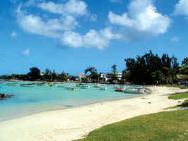
Grand Bay
Grand Bay was the first area of the island to fully experience the tourist boom. A shopping and leisure paradise, Grand Bay also happens to be the area where Mauritians head for when they want a fun-filled night out (restaurants, bars and discos). Recently renovated, La Cuvette beach is well worth a visit.

The Triolet Shivala
The longest village on the island, Triolet offers an opportunity to visit the biggest Hindu temple, the Maheswarnath, first built in 1819 in honour of the Gods Shiva, Krishna, Vishnu, Muruga, Brahma and Ganesha.

The Labourdonnais Orchards
Discover a large variety of tropical fruit trees, colourful and perfumed exotic flowers. Trips on mountain bikes or hiking are possible

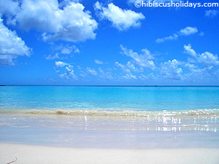
Pereybère
The wonderful Pereybere public beach is popular because of its shopping facilities, restaurants and pubs.

Balaclava Ruins
A few metres away from Baie aux Tortues, which 17th century sailors named after the many tortoises in the area, can be found the ruins of the old Balaclava estate. Visitors will be able to see the sea walls, whose initial foundations were laid down by Mahé de Labourdonnais.

East:
Flacq Market
Flacq is one of the most important villages in Mauritius. This meeting point for inhabitants of the East boasts the country’s largest open air market. The extremely colourful market attracts a large number of people.

The Waterpark Leisure Village
Enjoy unforgettable moments sliding on the giant chutes, with family or friends. Relaxation and pleasure guaranteed.

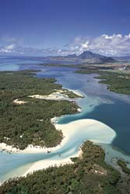
Ile aux Cerfs
Ile aux Cerfs is a paradise for water sports and has the most beautiful beach in Mauritius. You cannot afford to miss this tiny island, delicately poised on the ocean, a real pearl in the Mauritian landscape.

South East:
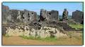

Dutch Ruins
At Vieux Grand Port, the oldest settlements in Mauritius, you can see the ruins of the first Dutch fortifications. Excavation work is underway in a bid to uncover an important part of Mauritian history

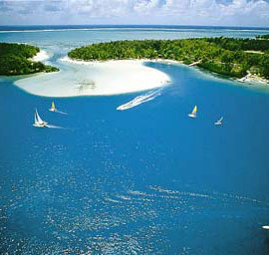
Ile aux Aigrettes
Owing to the remarkable work accomplished by the Mauritius Wildlife Fund, the island has become an international standard for the protection of natural resources and endangered species. A few of the world’s rarest birds, including the kestrel, can be seen there. You can also discover the extremely rare Pink Pigeon, the Green Gecko Phelsuma and the Aldabra giant tortoise.

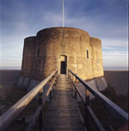
Mahebourg
Mahébourg is one of the main fishing villages on the island. Built on the magnificent Grand Port Bay it was founded in 1804 by the French G
Martello Towers
The Martello Towers represent the scene of the ancient rivalry between old colonial powers and the ingenuity of mankind. They are a milestone in the island’s history; they symbolise the end of slavery and the beginning of Indian immigration.

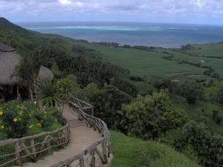
Domaine du Chasseur
Nestling in the Anse Jonchée hills, the Domaine des Grand Bois has splendid hunting grounds covering an area of 900 hectares. Stags, monkeys and boars live amidst the luxuriant vegetation of the hillside.One can watch a few species of endangered birds, including the kestrel. The Domaine contains four thatched-roof bungalows and a restaurant with a panoramic sea view. Take an opportunity to enjoy a delicious meal of venison and seafood.

Souillac
A small seaside resort along the rugged coast of the Savanne district. A famous feature is the garden overlooking the sea and named after Dr. Charles Telfair. A popular viewpoint is found at the southern end of the village, right on the cliff top: Gris Gris.

West:

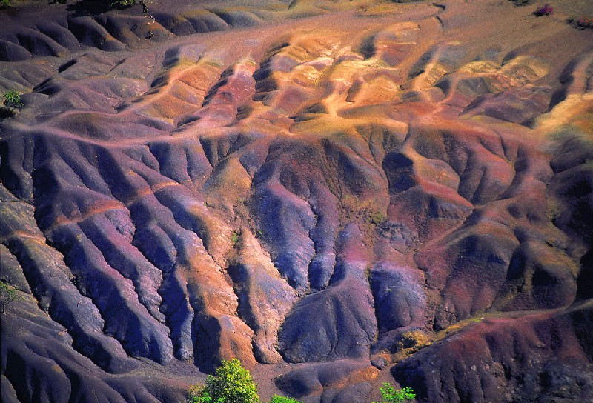
Chamarel
A winding road leads from Case Noyale village to the coloured earths of Chamarel: an undulating landscape of different and contrasting shades of colours. The different shades of blue, green, red and yellow are apparently the result of the erosion of the volcanic ash. The neighbouring waterfalls of Chamarel rise from the moors and the native plant life. The site possesses a rare beauty.
Some «Table d’hôtes» have been recently created in the Chamarel
Village where you can enjoy the taste of typical Mauritian cuisine.

Salt Pans
Owing to the exceptional high level of sunshine the district receives, Tamarin is naturally the heart of salt production in Mauritius.

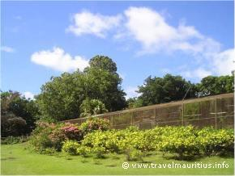
Casela
Situated in the Rivière Noire district, the bird park stretches over 25 hectares and contains more than 140 bird species from all five continents. Other attractions include fish ponds, tigers, tortoises, monkeys, deer and orchids.

Yemen
Yemen Reserve may not be the largest game reserve on the island, but there is still lots to see. You will be able to get close to the herds of deer, as well as admire some splendid species of Mauritian fauna. A few rustic kiosks available in the reserve provide an unobstructed view of the sea. There you can sip a local punch while watching the sun going down.

Inland:

L’Aventure du Sucre
Visit an interactive and ultra modern exhibition situated at the heart of an ancient sugarmill and discover the fascinating history of Mauritius and its sugarcane adventure exposed over 5000 sq meters! Then, let yourself be tempted by our tropical boutik with its unique gifts, souvenirs and tasting of special unrefined sugars as well as local rum. Do not miss the opportunity to relish authentic Mauritian cuisine with refined flavours at our restaurant "Le Fangourin".
Open 7 days a week from 09h00 to 18h00 - Free access to the restaurant and the Village Boutik
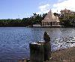
Ganga Talao - Grand Bassin
Beyond La Marie and Mare-aux-Vacoas is found one of the two natural lakes of Mauritius. It rests within the crater of an extinct volcano. Ganga Talao is an important pilgrimage site and many Mauritians of the Hindu faith walk there during the Maha Shivaratri
festival or the night fasting dedicated to Shiva.

Black River Gorges
This national park of 6,574 hectares was created in 1994 for the protection of Mauritius’ remaining native forests. Visitors can enjoy magnificent landscapes, with endemic plants and rare bird species. A trail leads from the Pétrin information centre to an area of typical plant life and to a conservation area. Orchids.
Eureka
An old Creole residence built in 1830, Eureka is an essential place to visit during your stay in Mauritius if you wish to immerse yourself in tropical sweetness.

ACTIVITIES

BLUE SAFARI SUBMARINE
This is the only operator of real submarines in the Indian Ocean. At 35 mts depth it’s a fabulous experience. The submarine is v comfy and sophisticated. Great security and A/C. anyone can do this from 2 yrs to 90 yrs !
The dive is 40 mins and the whole trip takes 2 hrs from start to finish. During the descent the colors change from red and at 20 mts it becomes brown, then violet at 30 m and finally blue at the deepest point of your dive.
For your photos we recommend 400 – 1000 ASA film, no flash and manual focus. There are photo souvenirs and video films on sale.
There are 2 submarines, one carrying 10 pax and the other with 5 pax. Pls note that every head on board is counted as a pax hence if there are 10 adults and 1 infant, we cannot accommodate all in one submarine. They will need to be split up.
Once the bookings for this excursion has been made, the same is Non refundable and will not be cancelled.
U will receive a certificate at the end of your dive.

UNDERWATER SCOOTER
This is akin to the underwater walk.
U are taken only 3 mts down.
You are allowed to be underwater for 30 mins.
Basically u can steer a scooter underwater which is harnessed to a rope being guided from the surface. U have the usual oxygen masks etc.
A person from the Scooter company will pilot u and u need to steer your scooter behind him.
This is a couple experience as 2 ppl sit on each scooter at a time.

DOLPHIN CRUISE
This tour departs at 0700 hrs.
Breakfast is served on board the catamaran sailing along the Black River, which is along the West Coast.
There is a barbecue lunch that is served on board. For vegetarians food can be prepared live on board.
U are taken to a little island just off the coast where the Dolphins are and return back around 1600 hrs.
Then on its time to head back to your hotel.

RODRIGUES ISLAND

This is a small island right next to MRU. There are daily MK services to Rodrigues. The island is v similar to MRU and hence not highly recommended. Its nice to know about this option though. The infrastructure is not as great as it is in MRU. Its a volcanic island 18km (11mi) long and 8km (5mi) wide, Rodrigues is in many way a miniature Mauritius. It's surrounded by coral reefs, covered with similar vegetation and landscapes, and blessed with an equally tropical climate. Rodrigues isn't quite as lush as Mauritius, but neither is it thick with tourists. The pace of life is more relaxed and the people prone to stop and chat. On the down side, it's more likely to be hit by the cyclones that plague the region. The last big one, Cyclone Bella, swung through in early 1991, bringing with it winds in excess of 200km/h (125mph).
The island is relatively small and perfect for rambling around at leisure. Hiking is good around Mt Limon and Mt Malartic, the island's two highest points at more than 390m (1280ft). The best coastal hiking leads from Port Mathurin around the eastern coastline to Port Sud-Est. Point Coton on the eastern coast has the best beach on the island, but there are other good ones at St François, Trou d'Argent and Petit Gravier. Caverne Patate in the south-west boasts some worthwhile spelunking opportunities. Diving is the big attraction of the waters around Rodrigues - you can arrange a trip through one of the big hotels. Several of the tiny islands just off Rodrigues, such as Île Cocos and Île aux Sables, are nature reserves and require permits to visit; others, such as Île aux Crabes and Île Hermitage, are just as beautiful and are open to the public.
Rodrigues lies about 560km (350mi) north-east of Mauritius. The two islands are connected daily by air and several times per month by sea. Keep in mind there's a minimum stay of 5 days and a maximum of 30.

HOTEL STAY IN MAURITIUS:
Casurina
Gold beach Hotel
Plantation resort
Indian resort
Maritim hotel
Meridien hotel
Hilton Hotel

INDIAN RESTAURANTS:

Taj Mahal- Grand Bay Resort, Royal Bay
Tanjore Le- Ventura Hotel Complex, Grand-Baie
Cilantro Taj Exotica- Mauritius, Flic en Flac
Salaam Bombay- Royal Rd, Telfair
Tandoor Mahal-
Indra-
Cari Poule- Avenue Duke of Edinburgh
Carri Poulé- Ave Duc Edimbourg
Indra- Domaine Les Pailles
Kohinoor
Mystic Masala Vegetarian- Main Mall
Shenaz- Angle des rues Gonin/Geoffroy
TANDOORI- Victoria Square
Gold Nest
Vibha
Magal Mahal
Tannur- Route St Jean

